Weather Report

Jake Hatcher

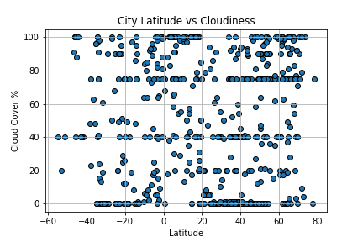

Latitude has no effect on cloud cover within the given ranges

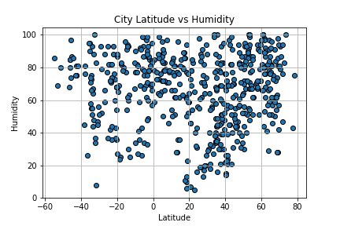

Latitude has little effect on Humidity

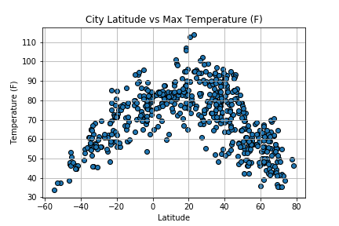

There is a visible correlation between latitude and maximum temperature, centering around just north of the equator. The center being biased towards the northern hemisphere is likely due to the current seasonal positioning of the planet.

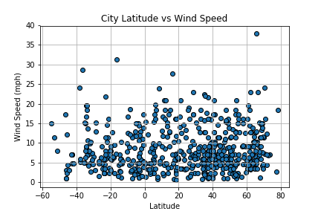

No obvious trend.